NAME : GOWTHAM S
ROLL NO : 24BAD028

EXPT NO:2 | LOAD AND VISUALIZE A DATASET USING TABLEAU and PowerBI
DATE: 10.07.2026

PRE-LAB QUESTIONS

- Why is Tableau a preferred tool for data visualization?
Tableau is preferred because it provides interactive dashboards, easy drag-and-drop features, fast data analysis, multiple visualization options, and supports connections to various data sources.

- What is the primary use of a line chart in data analysis?
A line chart is mainly used to display trends and changes in data over time, making it ideal for analyzing stock prices and financial performance.

- When would you use a tree map instead of a bar chart?
A tree map is used to compare hierarchical data or show proportions of categories when there are many groups, saving space effectively.

- What is the significance of filters in Tableau visualizations?
Filters allow users to display only relevant data, making visualizations interactive, reducing unnecessary information, and helping users focus on specific insights efficiently.

- How does Tableau handle geographic data for visualizations?
Tableau automatically recognizes geographic fields like country, state, city, latitude, and longitude, enabling users to create interactive maps without manual configuration.

IN-LAB EXERCISE:
OBJECTIVE:
To load a dataset into Tableau, create a variety of visualizations, and derive insights from the data using different chart types available in Tableau.

PROCEDURE:

Dataset Selection:
Use the Global Superstore Sales Dataset (available on Kaggle or Tableau's sample datasets).
Ensure the dataset includes fields like Order Date, Category, Region, Sales, Profit, and Customer Segment.

Data Loading:
Open Tableau and connect to the dataset.
Review the dataset structure, field data types, and missing values.
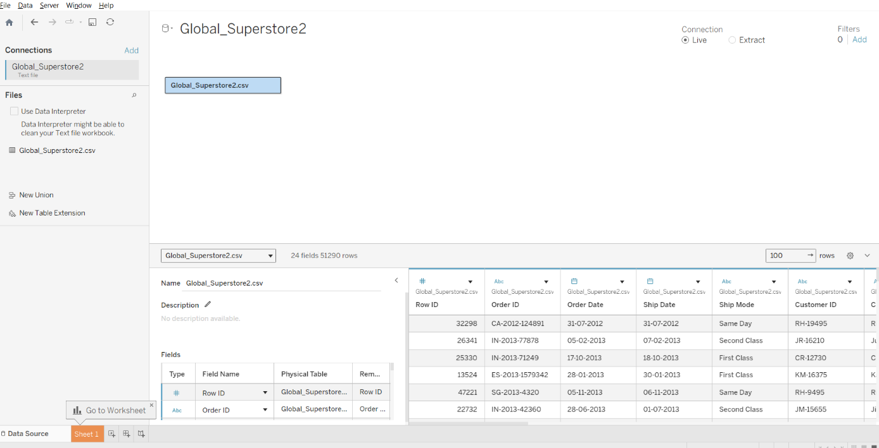

Chart Creations (Step-by-Step):
- Bar Chart:
Objective: Compare total sales by region and category.
Plot Region on the x-axis and Sales on the y-axis. Add Category as a color dimension.
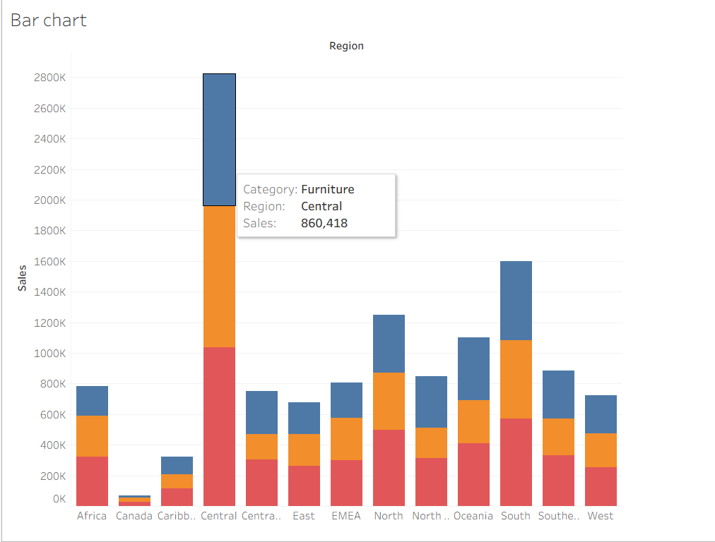

Line Chart:
Objective: Visualize sales trends over time.
Place Order Date on the x-axis and Sales on the y-axis. Set granularity to Month and color by Category.
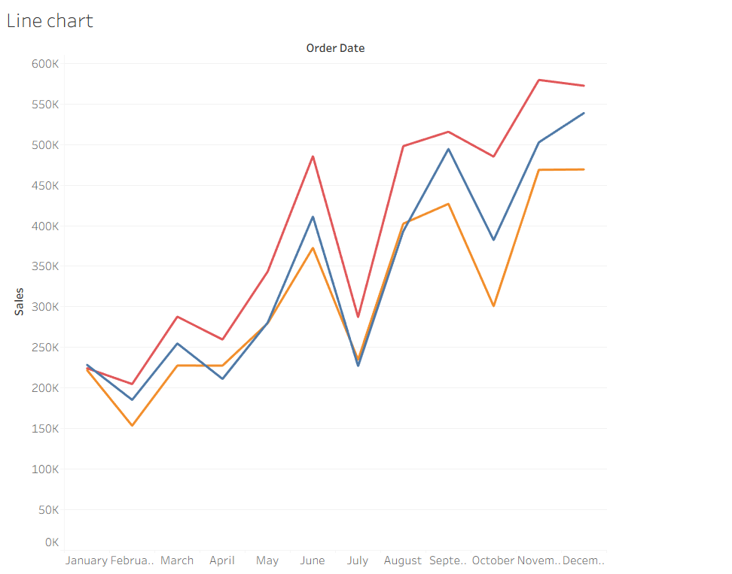

Pie Chart:
Objective: Show sales distribution by product category.
Assign Category as the dimension and Sales as the measure.
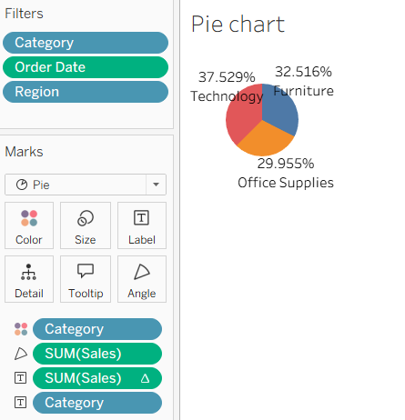

Scatter Plot:
Objective: Examine the relationship between profit and sales.
Plot Profit on the x-axis and Sales on the y-axis.
Use Sub-Category as the color dimension.

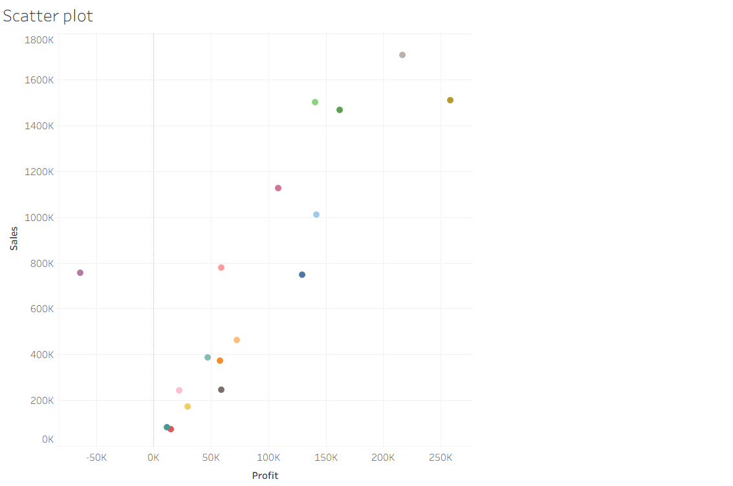

Heatmap:
Objective: Compare sales across categories and regions.
Use Region and Category as dimensions.
Use Sales as the measure and apply color coding.
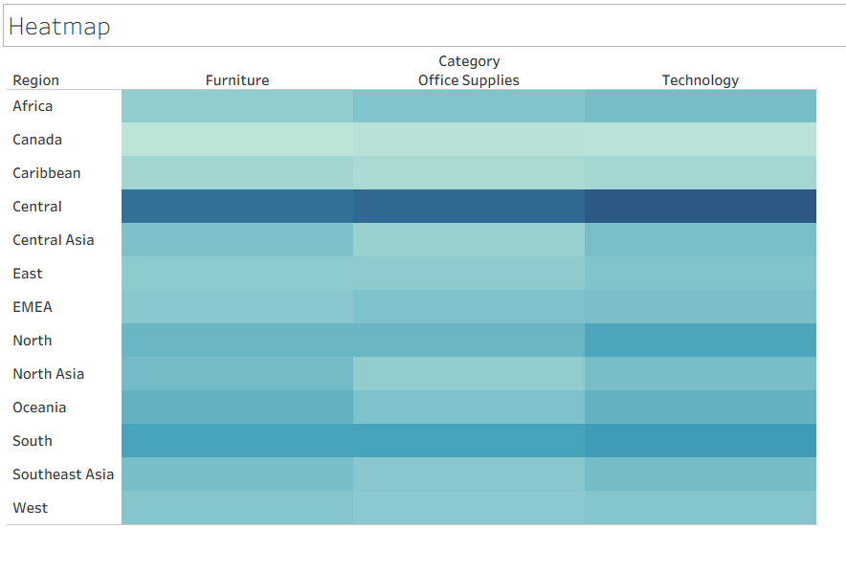

Geographical Map:
Objective: Visualize total sales by country.
Set Country as the geographical field.
Use Sales to define size and color gradients.
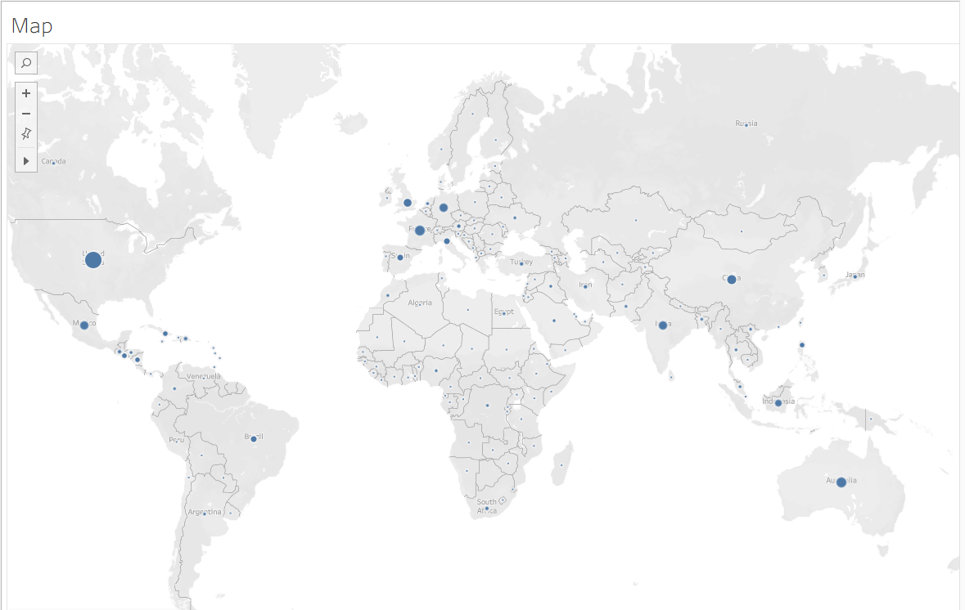

Tree Map:
Objective: Display sales distribution by category and sub-category. Use Category and Sub-Category as dimensions, and Sales as the measure.
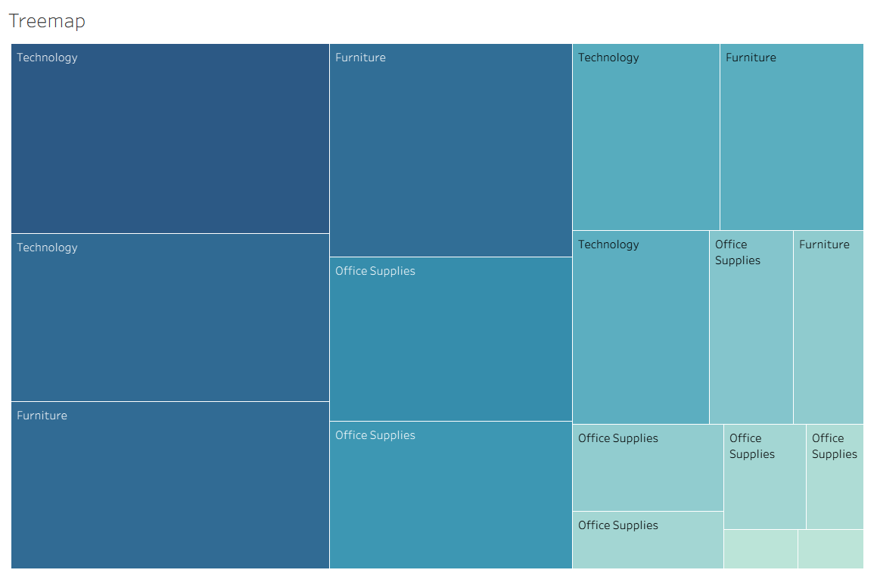

Customization and Interactivity:
Add filters to explore data subsets interactively (e.g., by year, region, or category). Include annotations, labels, and formatting for clarity.

Dashboard Creation:
Combine all charts into a single dashboard to present a cohesive story. Add interactive filters and tooltips for dynamic exploration.
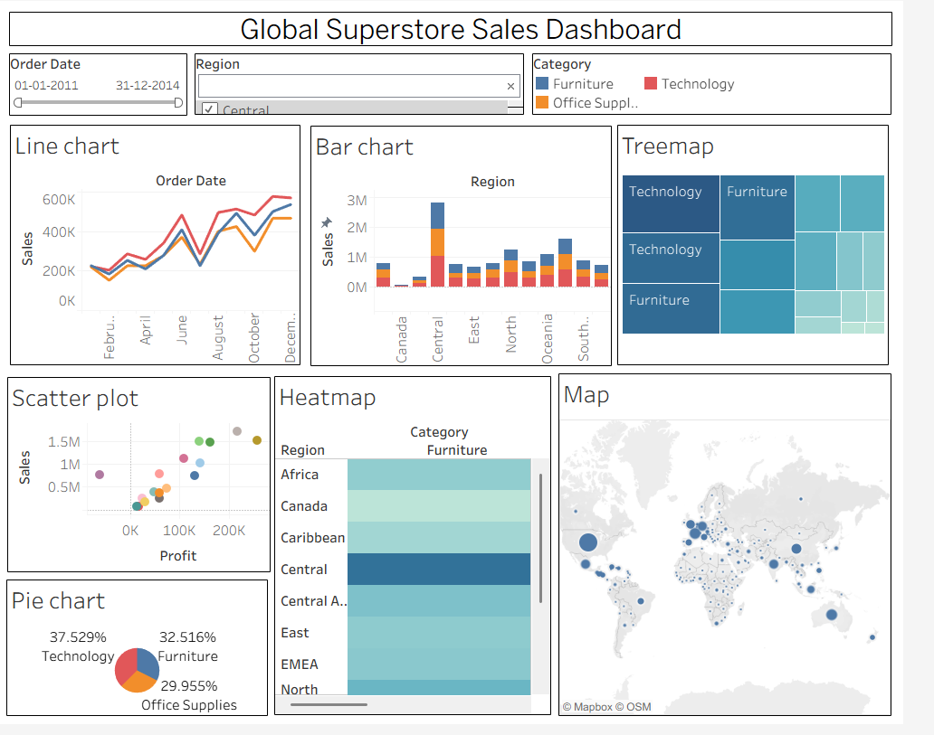

Experiment Dataset:
Global Superstore Sales Dataset
Source: https://www.kaggle.com/datasets/apoorvaappz/global-super-store-dataset

Fields Used:
Order Date Region Category
Sub-Category

Sales
Profit
Country

POST-LAB QUESTIONS

Bar Chart:
1.What regions had the highest and lowest total sales?
The Central region recorded the highest total sales, while Canada had the lowest total sales among all regions.

2.How does the performance of categories vary across regions?
Technology generally performs best across most regions, followed by Furniture. Office Supplies contribute steadily but usually generate comparatively lower sales.

Line Chart:
1.Identify the month with peak sales.
December recorded the highest sales, showing a strong increase compared to the previous months.
2.Which category shows consistent growth in sales over time?
The Technology category shows the most consistent growth, maintaining the highest sales trend throughout the year.

Pie Chart:
1.Which category contributes the most to overall sales?
Technology contributes the highest share of overall sales, followed by Furniture and Office Supplies.
2.Are there any categories with negligible sales contributions?
No. All three categories contribute significantly, although Office Supplies has the smallest share.

Scatter Plot:
1.Is there a noticeable correlation between profit and sales?
Yes. There is a positive correlation—higher sales generally result in higher profits, although some products have high sales but relatively low profit.

2.Which sub-category shows the highest sales but low profit? Tables often generate high sales but relatively low or negative profits because of higher discounts.
- Heatmap:
1.Which region-category combination has the highest sales?
The Central – Technology combination shows the highest sales among the region-category combinations.
2.Identify any regions with poor sales performance across all categories.
Canada and the Caribbean show comparatively lower sales across most product categories

Geographical Map:
1.Which country has the highest total sales? The United States has the highest total sales, followed by Australia and France.
2.Are there regions with minimal or no sales? Yes. Some countries in Africa and smaller regions show comparatively low sales, while no major region has zero sales.
- Tree Map:
1.Which sub-category dominates the sales in each category?
Furniture: Chairs
Office Supplies: Storage
Technology: Phones
2.Are there any sub-categories with unexpectedly low sales?
Yes. Labels and Fasteners contribute the lowest sales among all sub-categories.

Dashboard:
1.What insights can you derive when combining all visualizations?
The dashboard reveals sales trends, regional performance, category contributions, profit relationships, and geographic distribution, enabling quick identification of top-performing products and markets.
2.How do filters enhance the utility of the dashboard?
Filters allow users to analyze specific regions, categories, and date ranges, making the dashboard interactive and providing focused insights for better decision-making.

Description | Max Marks | Marks Awarded
Pre Lab Exercise | 5
In Lab Exercise | 10
Post Lab Exercise | 5
Viva | 10
Total | 30
Faculty Signature

ASSESSME

